# INTRODUCTION

* 1. **1.1 Overview**

The introduction of virtual classrooms has altered how we learn and teach, drastically altering the landscape of online education. The online education system is thoroughly examined in this in-depth examination, "Unveiling The Virtual Classroom," which offers insights into its advantages, difficulties, and potential in the future. In this project, the online education data set have been analyzed and virtualized useful findings.

* 1. **1.2 Purpose**

An in-depth analysis of the online education system project can serve various purposes and stakeholders, depending on its scope and objectives. Here are some potential uses and benefits of this project:

**1.2.1 Educational Institutions and Administrators:**

**Curriculum Enhancement:** The project can help institutions identify areas where online education can complement traditional teaching methods, leading to a more comprehensive curriculum.

**Quality Improvement:** By assessing the effectiveness of existing online courses, institutions can make data-driven decisions to enhance the quality of their online offerings.

**1.2.2 Educators and Instructors:**

**Pedagogical Insights:** An analysis can provide instructors with insights into effective online teaching methods, including strategies for engaging students in a virtual environment.

**Professional Development:** Educators can use the findings to improve their online teaching skills, making them more effective and adaptable.

**1.2.3 Students:**

**Learning Resources:** An analysis can help students identify high-quality online resources and tools that can aid their learning process.

**Study Habits:** Students can learn about effective study habits and strategies for success in online courses, improving their academic performance.

**1.2.4 Policy Makers and Regulators:**

**Policy Formulation:** Insights from the project can inform the development of regulations and policies related to online education, ensuring quality and accessibility.

**Resource Allocation:** Policy makers can allocate resources to support the growth and improvement of online education based on the analysis.

# LITERATURE SURVEY

* 1. **Existing problem**

The performance of students in online education continues to be a subject of concern and investigation. This problem statement aims to explore the various factors influencing students' academic achievement and engagement in the online learning environment.

**2.2 Existing approaches or method to solve this problem**

Predicting students' performance in online education is a complex task that involves analyzing various factors and data points. Several existing solutions and techniques have been developed to help predict and improve student outcomes in online learning environments. Here are some notable approaches such as Learning Analytics, Machine Learning Models, Peer Comparison and Dashboard Analytics.

**2.3 Proposed solution**

This proposed system on online education system is to promote student success, retention, and satisfaction while optimizing the efficiency and effectiveness of educational processes. It provides data virtualization, Dashboard, storyboard and report on the dataset after collecting the data and completes the preprocessing. This data-driven approach aims to create a more supportive and engaging online learning environment for all students.

# THEORITICAL ANALYSIS

* 1. Block diagram

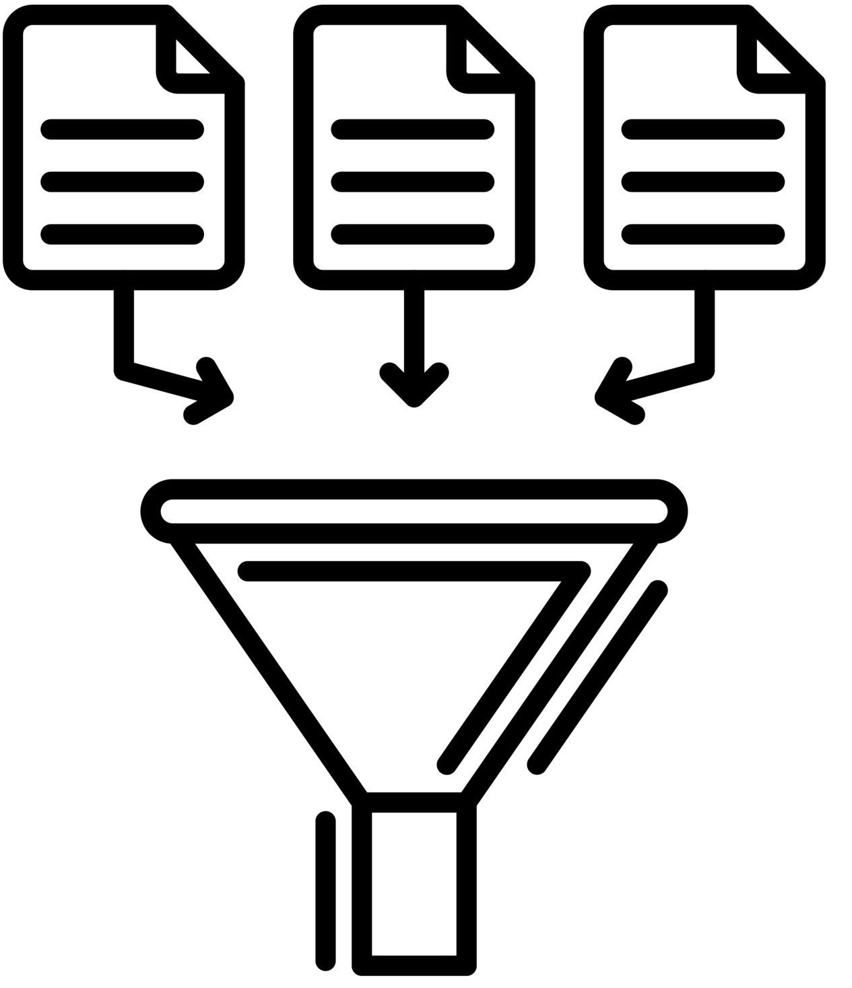

**Data Collection**

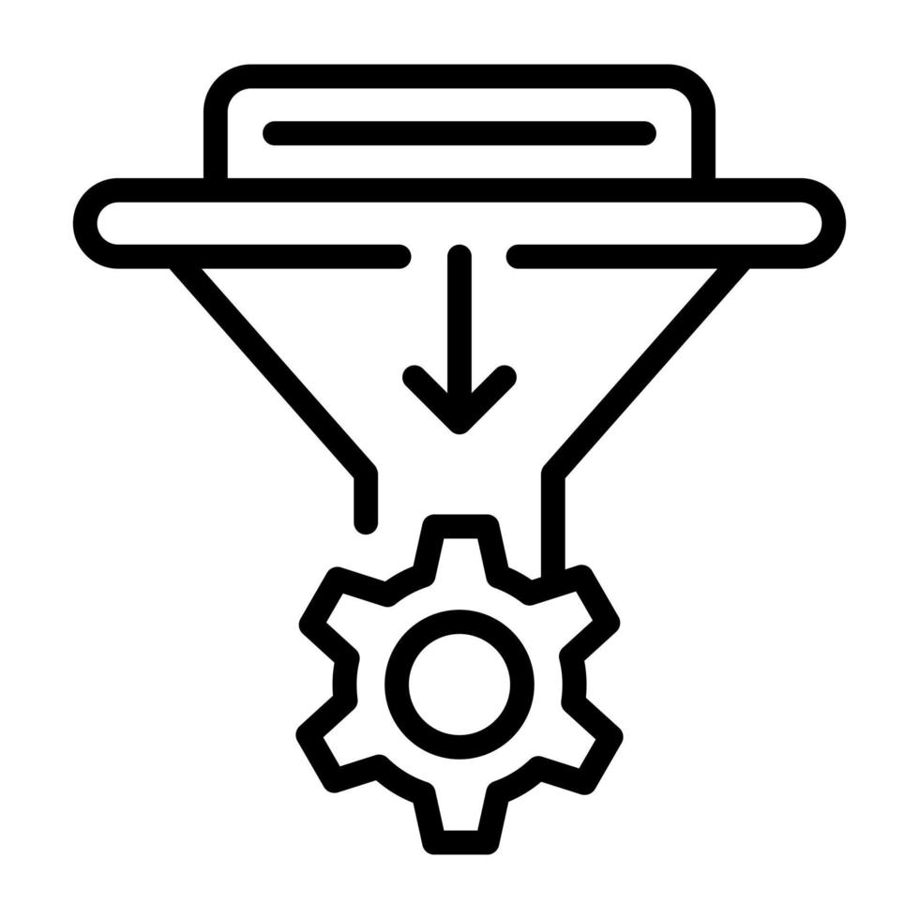

**Data Preparation**



**Data Visualization**

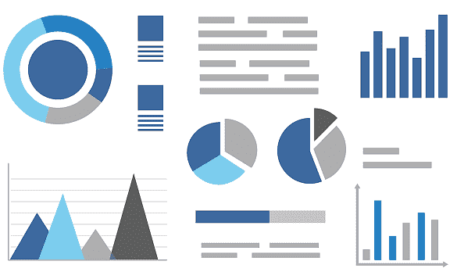

**Dashboard**

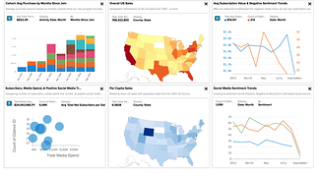

**Storyboard**

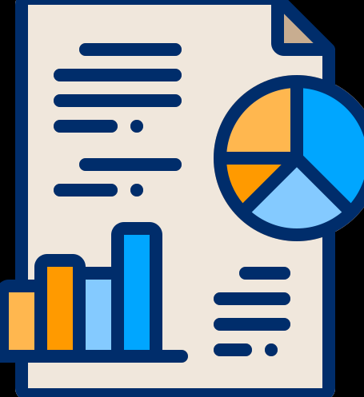

**Report**

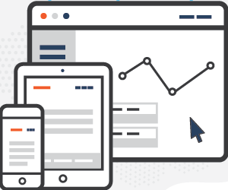

**Performance Testing**

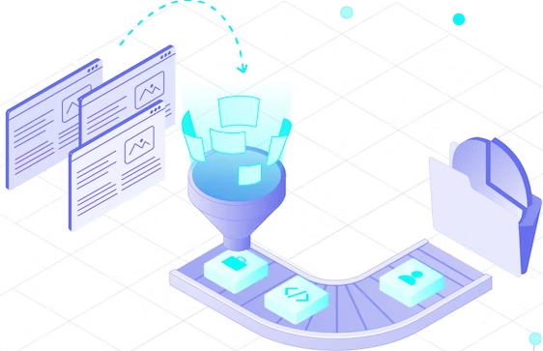

**Web Integration**

Figure 3.1 Block Diagram

**3.1.1 Data Collection:**

Data collection is the process of gathering and measuring information or data on a specific topic or subject of interest. It is a crucial step in various fields and industries, including research, business, healthcare, social sciences, and more. The collected data serves as the foundation for analysis, decision-making, and gaining insights into the phenomenon being studied. Data collection begins with a clear understanding of the purpose and objectives of the study or project. Researchers or organizations define what information they need to collect and why. This step helps in shaping the entire data collection process.

**3.1.2 Data Preparation:**

Data preparation, also known as data preprocessing or data cleaning, is a crucial step in the data analysis pipeline. It involves transforming raw data into a suitable format for analysis, ensuring its quality, and making it ready for modeling or further exploration. Here's a detailed description of data preparation:

**Data Collection Review**

**Data Cleaning**

**Handling Missing Data**

**Removing Duplicates**

**Data Transformation**

**Normalization and Standardization**

**Categorical Variable Encoding**

Feature Engineering

**3.1.3 Data Visualization:**

**Data visualization is the graphical representation of data to help people understand, interpret, and draw insights from it. It is a powerful tool for conveying complex information, patterns, and trends in a clear and intuitive manner.**

**3.1.4 A dashboard**: It is a visual interface that displays key information, data, metrics, and performance indicators in a consolidated and easy-to-understand format. Dashboards are used in various fields and industries to provide users with real-time or summarized insights, facilitating informed decision-making.

**3.1.4 A Storyboard:**

In data analysis, a storyboard is a visual or written outline that helps organize and present the key steps, findings, and insights of a data analysis project in a structured and coherent manner. It serves as a storytelling tool that guides the audience through the data analysis process, making complex information more accessible and engaging

**3.1.5 A report:**

The report in data analysis is a structured document that communicates the results, findings, insights, and recommendations derived from the analysis of data. It serves as a formal and comprehensive way to present the outcomes of a data analysis project to stakeholders, decision-makers, or other interested parties. Writing a data analysis report is crucial for ensuring that the insights gained from the data are effectively communicated and can inform informed decision-making.

**3.1.6 Performance testing**:

In data analysis is a critical process that focuses on evaluating the efficiency, speed, scalability, and reliability of data analysis workflows, tools, and systems. It ensures that data analysis processes meet the performance requirements and expectations of the users.

**3.1.7 Web integration:**

In data analysis refers to the process of incorporating web-based data sources, web services, APIs (Application Programming Interfaces), and other online resources into your data analysis workflows. This integration allows data analysts and data scientists to access, collect, and analyze data from the web, enriching their analyses with external data.

* 1. **Hardware / Software designing**

**Hardware requirement:**

1. SSD is preferred & 500GB minimum
2. Intel i5 minimum or Intel i7 or i9 preferred

Software Requirement:

1. IBM Cognos

# EXPERIMENTAL INVESTIGATIONS

# Step 1: Data Collection

# All of the meta data for the columns described in the CSV files is contained in the data. We have 1 CSV file available:

# ONLINE EDUCATION SYSTEM REVIEW.csv

# csv File Source: <https://drive.google.com/file/d/1O39CDVV9CkPthvNO7z2GHbyxRPKm2Ey6/view?usp=sharing>

Column Description for Online education system  review:

* Gender: Gender of the student
* Home Location : Rural or Urban.
* Level of Education : UG, PG or school
* Age : age of the student
* Number of subjects :
* Device Type Used : device used to attend the online classes
* Economic status :  economic status of the family
* Internet facility in your locality
* Are you involved on any sports
* Family Size
* Do elderly people monitor you ?.
* Study Time(hours)
* Sleep time (hours)
* Time spent on social media(hours)
* Interested in gaming ?
* Have a separate room for studying ?
* Engaged in group studies ?
* Average marks scored before pandemic in traditional classroom
* Your interaction in online mode
* Clearing doubts with faculties online ?
* Interested in ?
* Performance in online
* Your level of satisfaction in online education

# Step 2: Data Preparation

# Cleaning the data to remove irrelevant or missing data, converting the data into a format that can be easily visualized, exploring the data to find patterns and trends, filtering the data to concentrate on particular subsets of data, preparing the data for visualization software, and making sure the data is accurate and complete are all steps in the data preparation process. This procedure assists in making the data readily comprehensible and suitable for visualization to reveal performance and efficiency.

# 

# Step 3: Visualization

# The following Visualization graphs are created and the screenshot has been attached in the Report field in this document.

1. Column Chart: Age(Years) by Your level of satisfaction in Online Education
2. Bar Chart: Internet facility in your locality by Your level of satisfaction in Online Education
3. Bar chart: Performance in online by Level of Education
4. Pie Chart: Time spent on social media (Hours) by Device type used to attend classes
5. Packed bubbles : Engaged in group studies? colored by Engaged in group studies? sized by Performance in online
6. Wordcloud: Average marks scored before pandemic in traditional classroom
7. Table: Economic status, Home Location and Performance in online
8. Radial Chart:
9. Line Chart: Performance in online by study time(hours)
10. Line Chart: Performance in online by sleep time(hours)

**Step 4: Dashboard**

By selecting the dashboard under "present data" after creating the explorations, a dashboard is constructed. The 'pin' option is located on the left side of the screen, and dragged the visualizations from there. 3 tabs are created for the dashboard.

**Step 5: Storyboard**

The intricacy of the analysis and the precise findings that need to be communicated will determine how many scenes there are in a storyboard for a data visualization analysis of the effectiveness and performance of online education. A storyboard divides the analysis into a number of steps or scenes and serves as a visual depiction of the data analysis process.

The following scenes are created.

Level of satisfaction regarding online education by age

Time spent on social media with different devices

Correlation between economic status, home & student online performance

**Step 6: Report**

Four visualizations is created in the report as follows

Student performance by level of education

Correlation between Economic Status and Performance

Effect of Social Media on Performance

Performance by interest of studying method

# FLOWCHART

**Performance Testing**

**Web Integration**

**Data Collection**

**Data Preparation**

**Data Visualization**

**Dashboard**

**Storyboard**

**Report**

# RESULT

# Data Preparation:

# 

# Data Visualization:

# 

# 

# 

# Dashboard:

# 

# 

# 

# Storyboard:

# 

# 

# 

# https://us1.ca.analytics.ibm.com/bi/?perspective=story&pathRef=.my_folders%2FOnline_Education_Story&action=view&sceneId=model0000018a7af9321f_00000003&sceneTime=0

# Performance Testing:

# 

# 

# Report:

# 

# Web Portal:

# 

# 

# 

# ADVANTAGES & DISADVANTAGES

**Advantages:**

**Useful for Educators and Instructors**

**Helps to Policy Formulation**

**To identify the Learning Resources**

**Disadvantages:**

**Clear data set is required for best analytical result**

# APPLICATIONS

Institution

Online platform industries

LMS Creators

# CONCLUSION

# The goal of this project is to examine the many facets of online learning in-depth, highlighting its benefits and drawbacks as well as its chances and difficulties. The findings of this experiment offered insightful information for educational institutions, decision-makers, and online learning platforms to improve the efficacy and accessibility of online education. This examination of the online education system adds to the continuing discussion about the direction of education and aids in the creation of a more open, interesting, and productive learning environment for the digital era.

# FUTURE SCOPE

Diverge real time data set to be used for the analysis in improve the insight findings.

# BIBILOGRAPHY

# Y. LIU, B. YANG and Z. QIU, "The Emotional Tendency Analysis of Social Network Evaluation on Online Education during the COVID-19 Pandemic," 2020 IEEE/WIC/ACM International Joint Conference on Web Intelligence and Intelligent Agent Technology (WI-IAT), Melbourne, Australia, 2020, pp. 735-740, doi: 10.1109/WIIAT50758.2020.00113.

# Z. Ling, "Online Education Data Application Analysis Based on Machine Learning Algorithms," 2021 International Symposium on Advances in Informatics, Electronics and Education (ISAIEE), Germany, 2021, pp. 126-128, doi: 10.1109/ISAIEE55071.2021.00038.

# Y. Almurtadha and M. Ghaleb, "Sentiment Analysis to Measure Public Response to Online Education During Coronavirus Pandemic," 2021 National Computing Colleges Conference (NCCC), Taif, Saudi Arabia, 2021, pp. 1-5, doi: 10.1109/NCCC49330.2021.9428838.

# Y. Xu, "Visualization Analysis for Articles Published in the Journal of Medical Education Online from 2010 to 2019 based on Citespace," 2020 13th International Symposium on Computational Intelligence and Design (ISCID), Hangzhou, China, 2020, pp. 330-333, doi: 10.1109/ISCID51228.2020.00080.

# APPENDIX

A. Source Code

Attach the code for the solution built.

**Note: Limit the report to 15 pages.**